1. Install the burn tool STVP: sttoolset_pack32.exe

After installation ，。

2. Double-click to open the software, as shown in the figure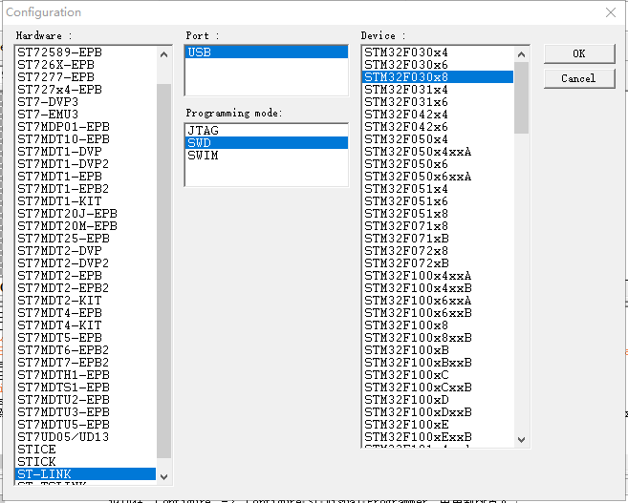

Click the above figure to set  ST-LINK --> SWD --> STM32F030x8，then click OK.。

It can also be reconfigured in“Configure”->“Configure ST Visual Programmer”。

3. Use ST-Link to connect computers and platforms. Pay attention to the ST-Link wiring sequence

4. Click on the file->open，select the file you want to burn with "xxx.hex"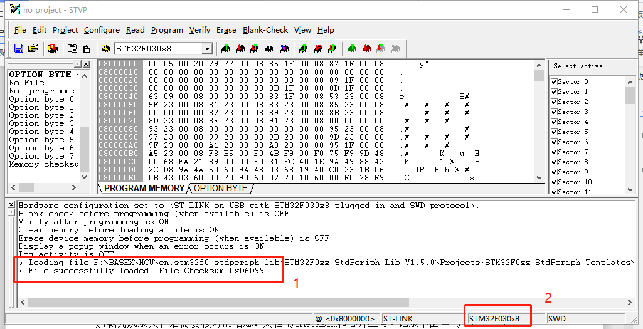

Information to check after loading the burn file: the checksum and chip type of the document.Record the information in the "1" and "2" red rectangular boxes in the figure below.Checksum is used for burn check and chip type for chip check.

5. Click the button in the "1" rectangle below to Erase current TAB.If you see the contents of the rectangle with "2" in it, it is erased successfully.

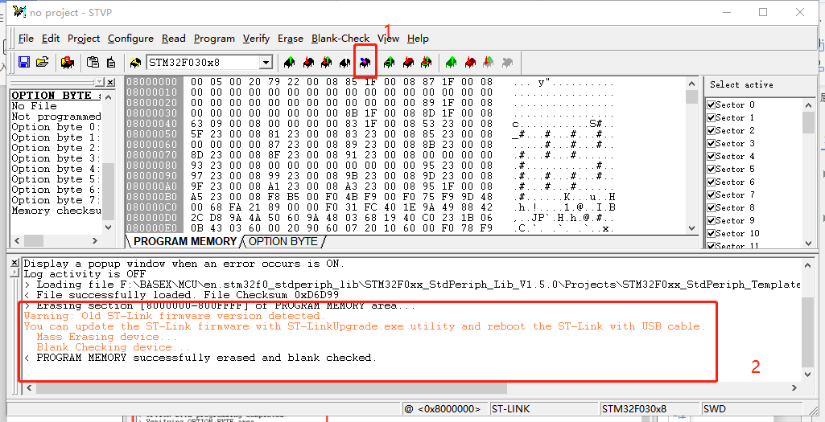

6. Click the button "Program All Tabs" in the rectangular box of "1" below to burn.If you see the contents of the rectangle with "2" in it, it means that you have successfully burned it.

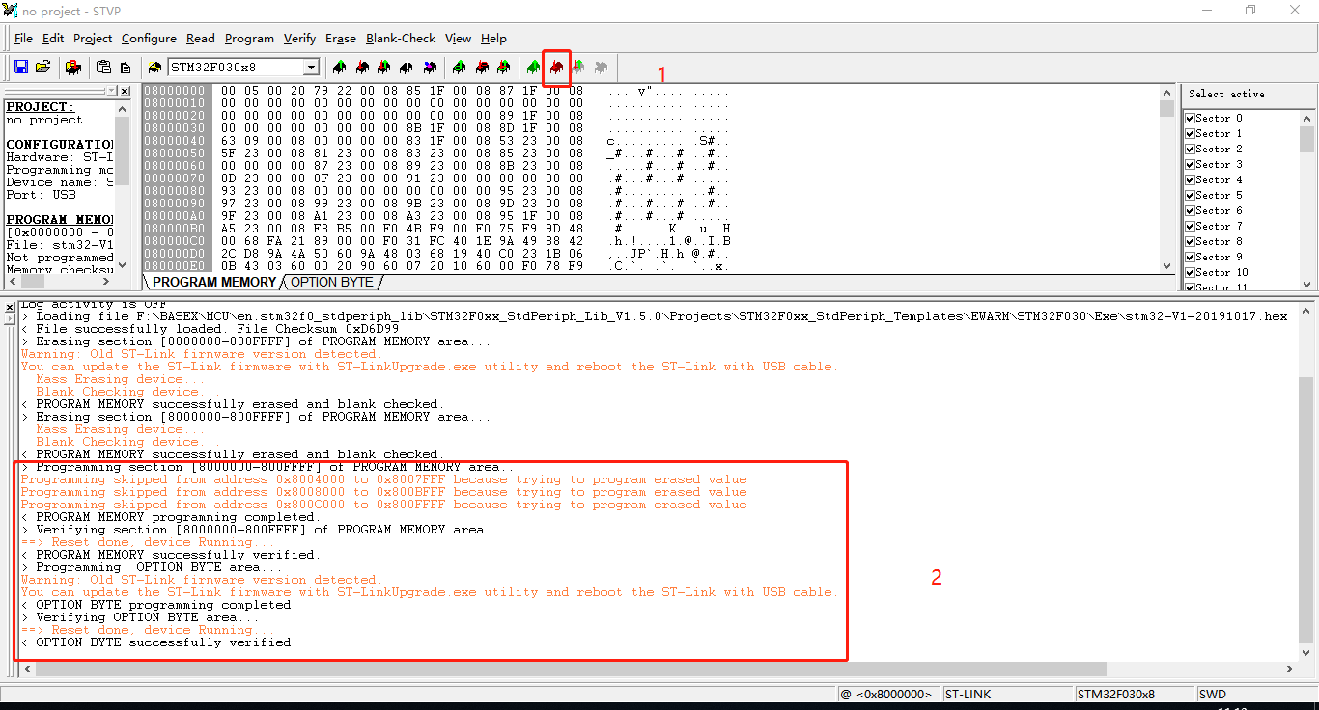

7. As long as the STVP interface is not closed, you can directly continue to erase and burn a platform

How to get the software version

1. Connect TX, RX, GND ports in the BASEX+ channel using the serial tool to PC or Open the back cover and connect to port TX, RX, GND on USART1 to PC。

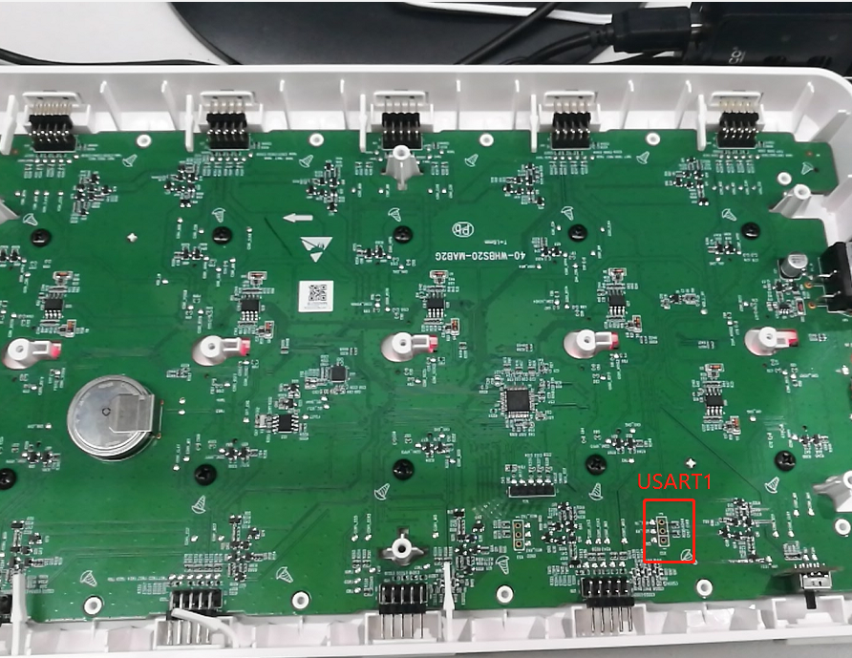

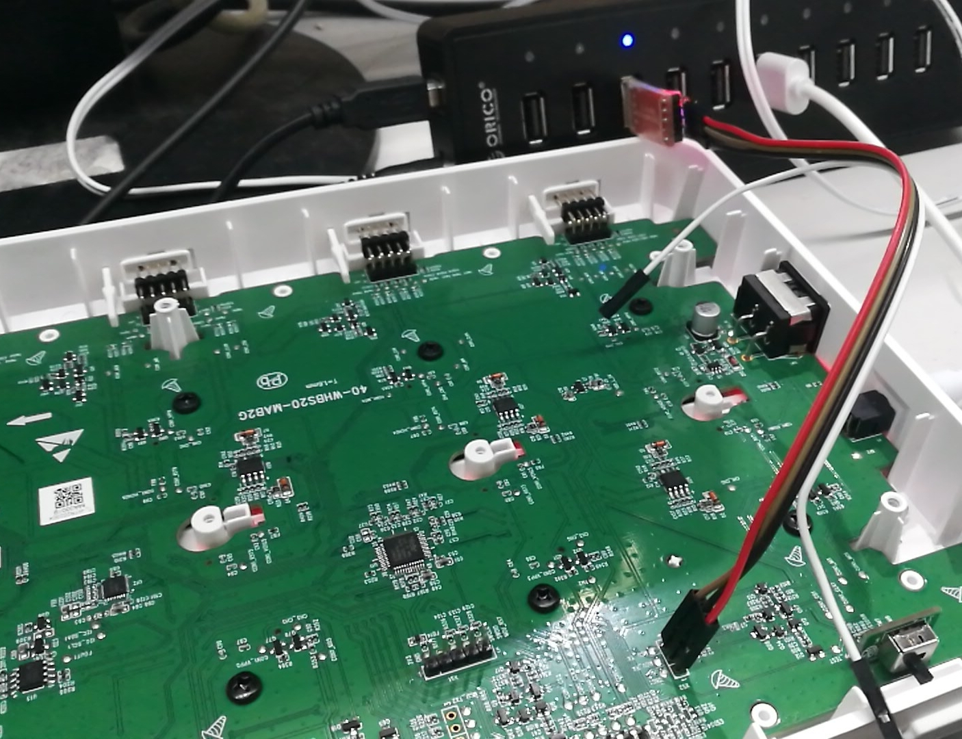

1. Use the serial port software to send the following instructions

Send：

|  |  |  |  |  |
| --- | --- | --- | --- | --- |
| The frame header | Data len | Order | Data | Check sum |
| 0xFF 0x55 | 0x00 | 0x07 | No | XX |

Return：

|  |  |  |  |  |
| --- | --- | --- | --- | --- |
| The frame header | Data len | Order | Data | Check sum |
| 0xFF 0x55 | 0x01 | 0x07 | Version | XX |

For example：

Send：FF 55 00 07 AD

Return：FF 55 01 07 01 AD

